Painting with Gouache: Materials list

Materials required for this class:

- A set of gouache paint tubes, preferably 18 colors with 1 larger tube of either permanent white or Titanium white. Best brands to get M.Graham, Holbien, Windsor Newton. I discourage the inexpensive stuff from Michaels or Hobby Lobby, they are just not good quality and end in poor results.
- Clamshell type Watercolor palette with a lid, I find mine on amazon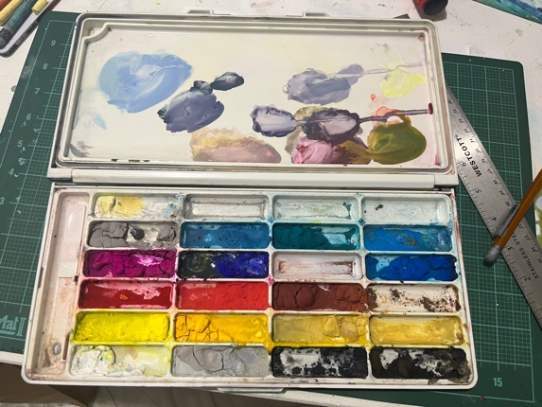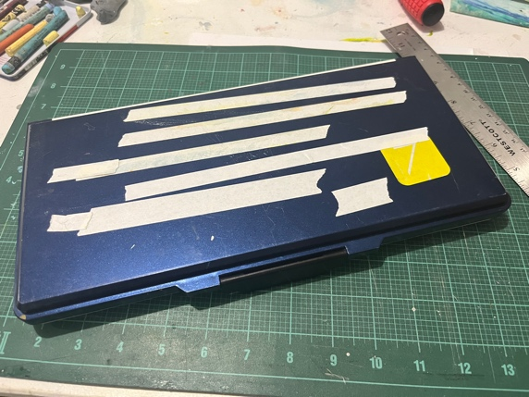

- In expensive synthetic brushes you can buy these at Michaels in a variety pack. They are what I use 90% of the time.
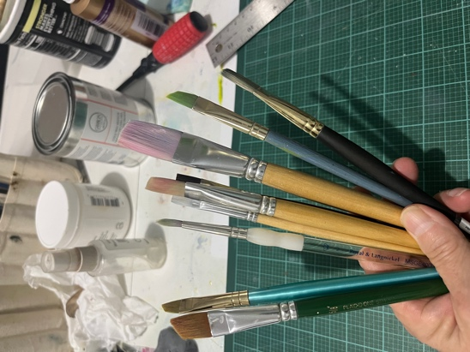

- A small spritzer bottle to keep the paint from drying out
‘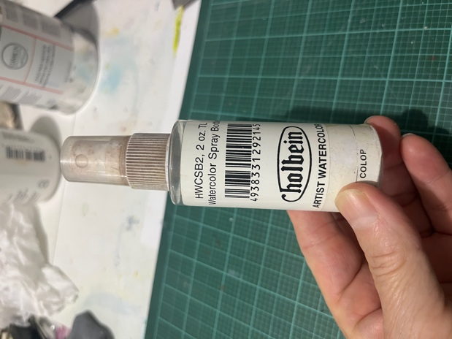

- Cold Press( rough texture) 140lb watercolor paper No need for expensive paper for this class I prefer Arches 9x12 or 11x14, we will paint a lot of small little squares the first day.
- White, artist tape, you can find this on any art supply site or amazon ½ in is good NO BLUE paint tape…
- Paper towels are a must
- Container for water in order to clean brushes as we paint

